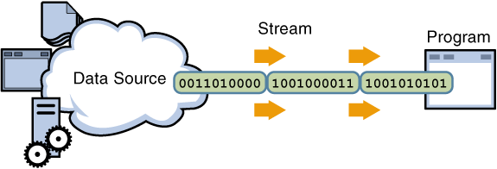

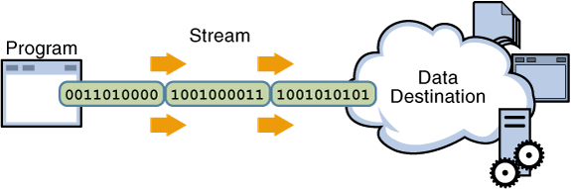

Basic Streams in JAVA
Java defines two types of streams. They are-
- Byte Streams :- These are the most basic type of Stream for input output operations and are used to process data byte by byte. Byte based streams generally end up calling by word “Stream” likeInputStream and OutputStream and are used to process a raw Byte at a time.
Some Exceptions are DataInputStream and DataOutputStream which are used to read and write Java standard datatypes like int, long, float and double.
- Character Streams :- These provide a convenient way for handling character inputs and output. These can be used for internationalization purpose as Character Streams uses UNICODE characters.
These streams end up calling by a word “Reader” or “Writer” like InputStreamReader, FileReader, OutputStreamWriter, FileWriter etc.

